Period One | 6:00-6:10
Period Two | 6:15-6:25
Period Three | 6:30-6:40
Period Four | 6:45-6:55
Period Six | 7:00-7:10
Period Seven | 7:15-7:25

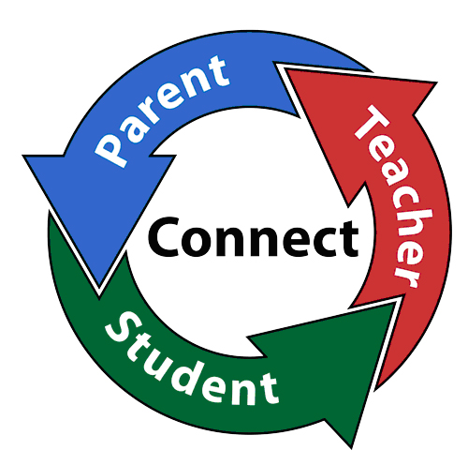

*Arts & Humanities Period 1, 2, or 3 periods: (in auditorium): Suicide Awareness Information
*Period 4, 6, or 7th Periods(in auditorium): Bully Hotline Information
*Please visit the information tables in the Great Hall!

